Lab Assignment 10

Fundamentals of Machine Learning

**NAME :** M Jeyapathy

**USN:** 22BTRAD016

Experiment10: Objective: To implement a decision tree using sklearn

1.Import necessary libraries (e.g., numpy, pandas, matplotlib, sklearn)

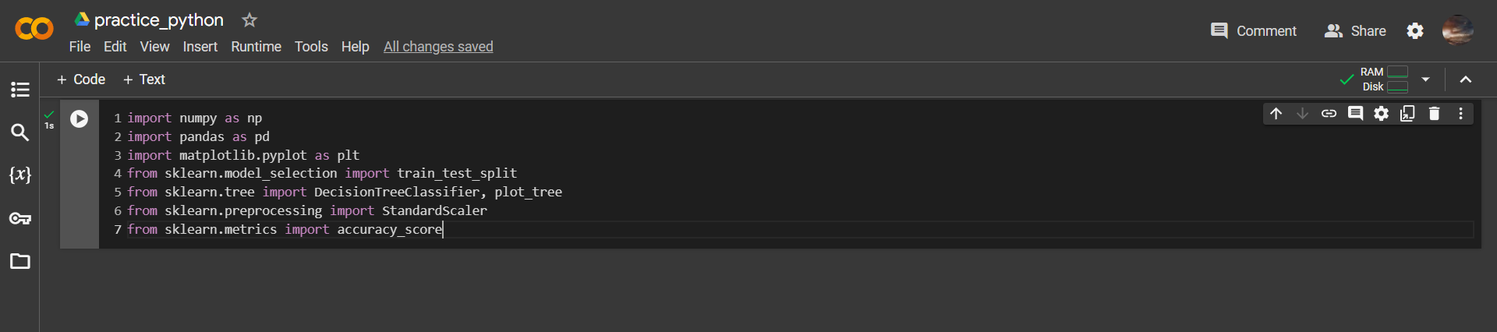

2.Load the dataset using pandas.

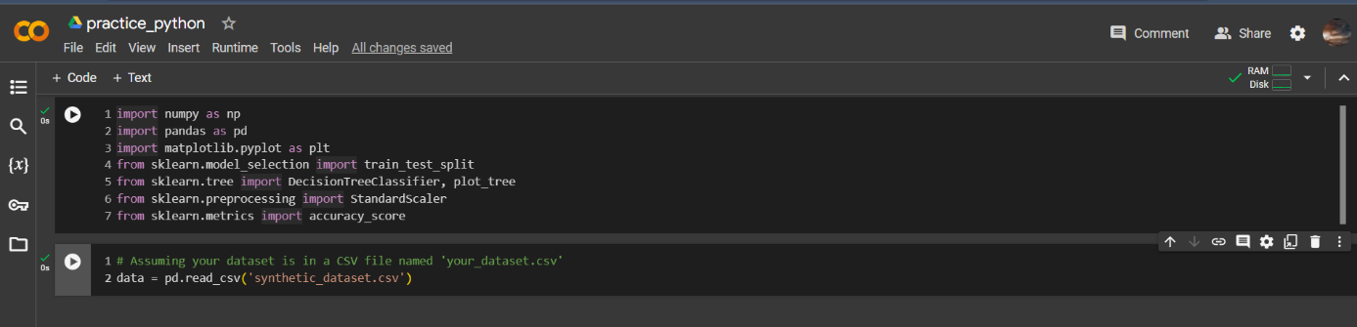

3.Preprocess the dataset using techniques like scaling and normalization.

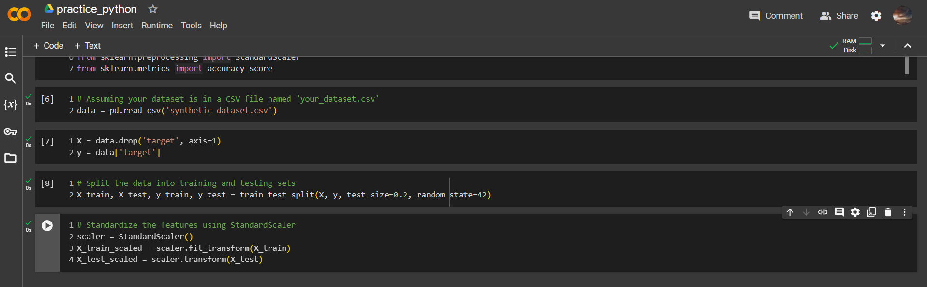

4.Create a decision tree model using sklearn.

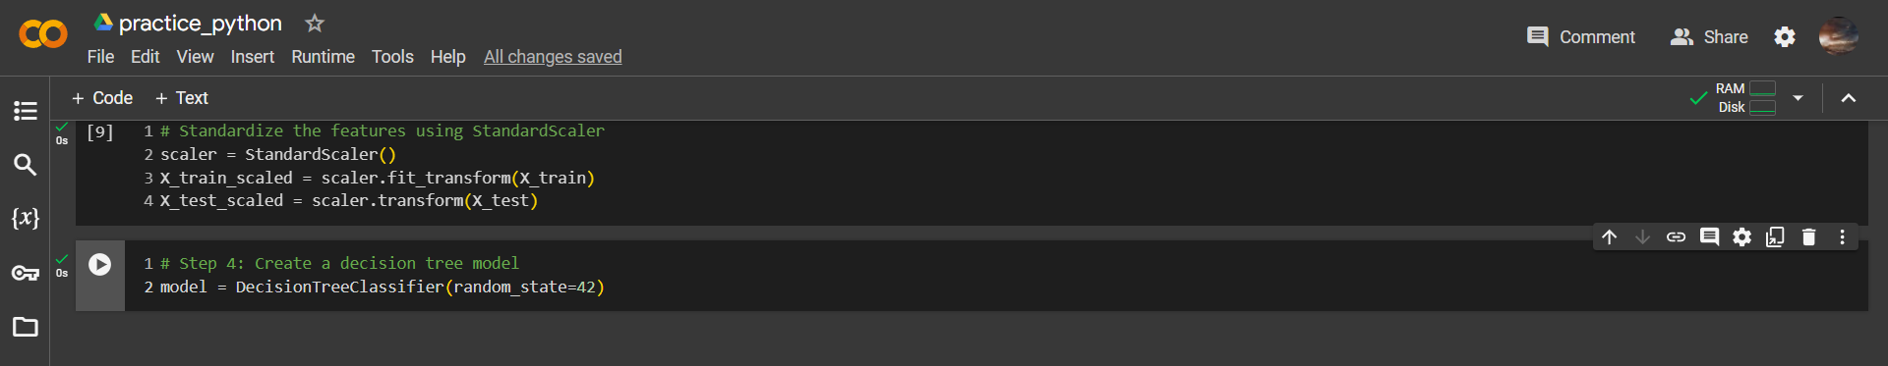

5.Fit the model on the preprocessed dataset.

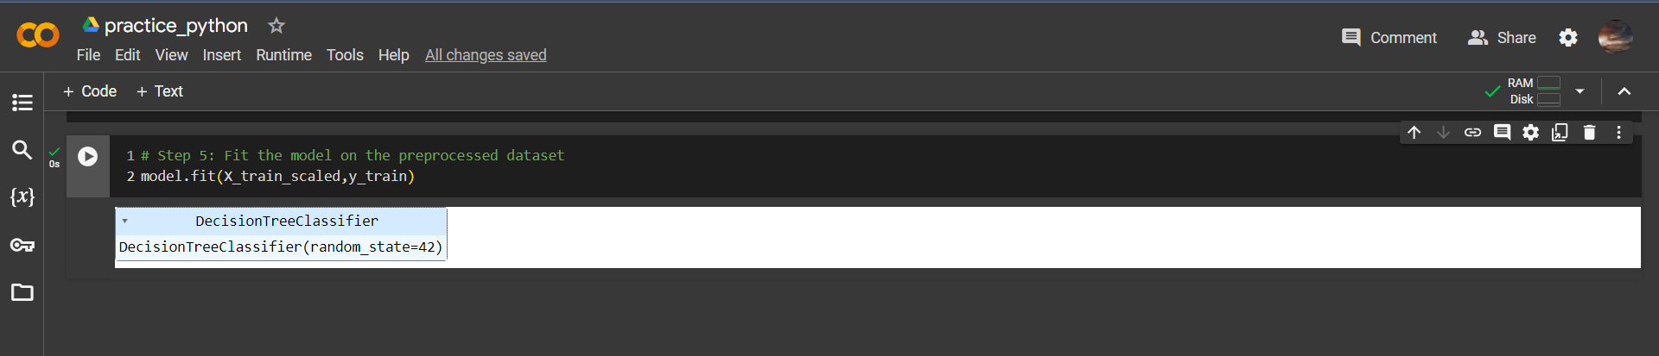

6.Visualize the decision tree using matplotlib.

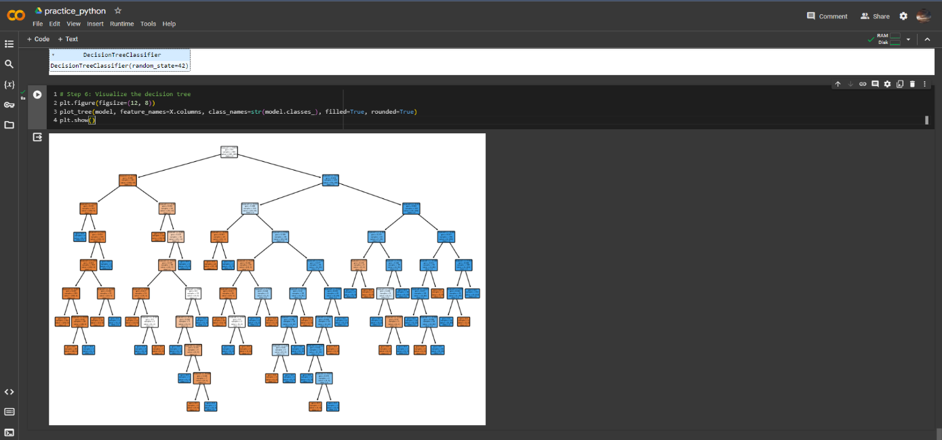

7.Evaluate the model using metrics like accuracy. Result: The decision tree model can predict the target variable based on input variables.

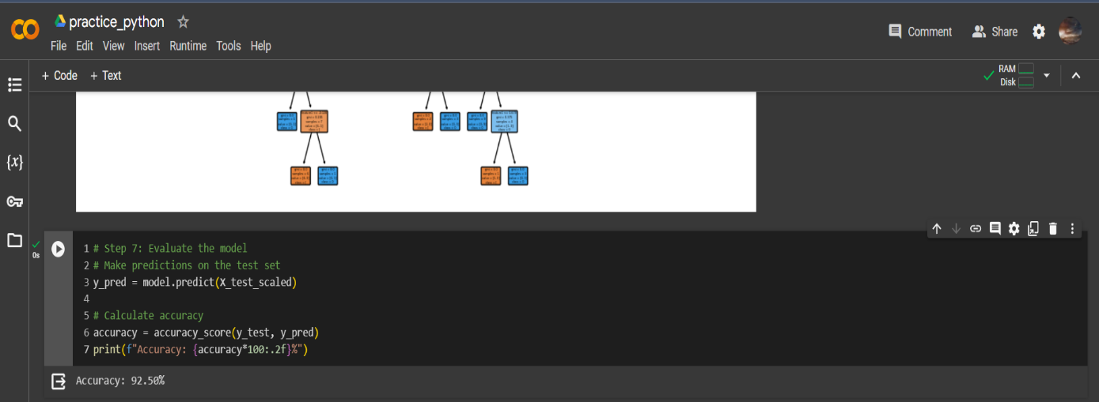

Github Link:

https://github.com/Jeyapathy/Machine-Learning